** *Heavy Duty End Yoke Identification***

**End Yoke/U-joint Type ___________**

Full Round All 4 caps have plates and 2, 3/8-24 bolts . Half Round 2 caps with plates and 2, 3/8-24 bolts, 2 caps without plates.

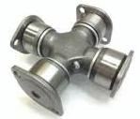 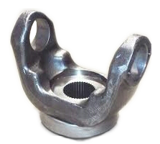 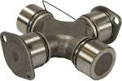 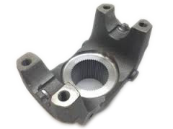

Spicer SPL Caps retained by a spring tab with 2 Rockwell RPL Caps retained by internal snap rings on

5/16 hex bolts on the shaft side. Caps retained the shaft side. Caps retained by 12 point,

by Cast Straps and 12 point 12mm bolts on the End Yoke side. 12mm head bolts on End Yoke side.

*SPL90/100 retained by snap rings not a spring tab.

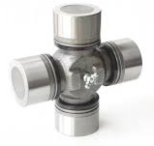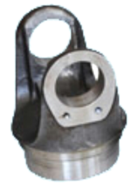 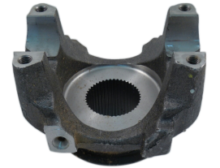 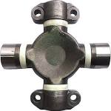 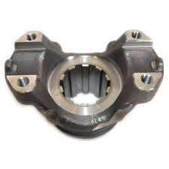

Driveshaft side Weld Yoke End Yoke

**U-joint Series___________**

For End Yoke type Full Round- Measure outside to outside of the ears of the yoke as if there was not a u-joint installed.

For End Yoke Type Half Round, SPL and RPL- Measure inside to inside of the nubs on the End Yoke.

1610 Cap Diameter 1.875 -Outside to Outside of the ears 5.312 (Full Round) -Inside to inside of nubs 5.312 (Half Round)

1710 Cap Diameter 1.938 -Outside to Outside of the ears 6.094 (Full Round)

-Inside to inside of nubs 6.190 (Half Round)

1760 Cap Diameter 1.938 -Outside to Outside of the ears 7.00 (Full Round)

-Inside to inside of nubs 7.094 (Half Round)

1. Cap Diameter 1.938 -Outside to Outside of the ears 7.547 (Full Round)

-Inside to inside of nubs 7.643 (Half Round)

SPL90/SPL100 Cap Diameter 1.625 - Inside to inside of nubs 4.957

SPL140 Cap Diameter 1.938 - Inside to inside of nubs 5.457

SPL170 Cap Diameter 2.166 - Inside to inside of nubs 6.456

SPL250 Cap Diameter 2.362 - Inside to inside of nubs 6.412

SPL350 Cap Diameter 2.559 - Inside to inside of nubs 6.772

RPL20 Round Cap Diam, shaft side 2.060 - Inside to inside of nubs 7.060

RPL25 Round Cap Diam, shaft side 2.060 - Inside to inside of nubs 8.380

RPL35 Round Cap Diam, shaft side 2.450

**Spline Count___________**

Count the number of splines.

**Spline Diameter___________**

Measure down in between the splines, straight across.

The largest distance possible.

**Hub/Seal Diameter___________**

Measure the outside diameter of the hub where the

seal rides.

**Length through the hole__________**

With the Yoke on a table, with the ears pointing up,

measure from where the Nut/Washer hits the yoke

down to the table.

**Center to end__________**

With the Yoke on a table with the ears pointing up.

Measure from the table up to where the center of the

U-joint cap would be.

**Counter bored? __________**

Is the spline counter bored on the hub end.

**Counter bore depth__________**

Measure how deep the spline is machined out from

the end of the Yoke.

**Deflector?** **___________**

Does your Yoke have a metal or plastic shield pressed

on the Yoke, on the hub end?

**Deflector Diameter__________**

What is the outside diameter of the deflector shield